The sales trends over time have been visualized, showing how sales have fluctuated on a monthly basis.

Sales Trends Over Time:

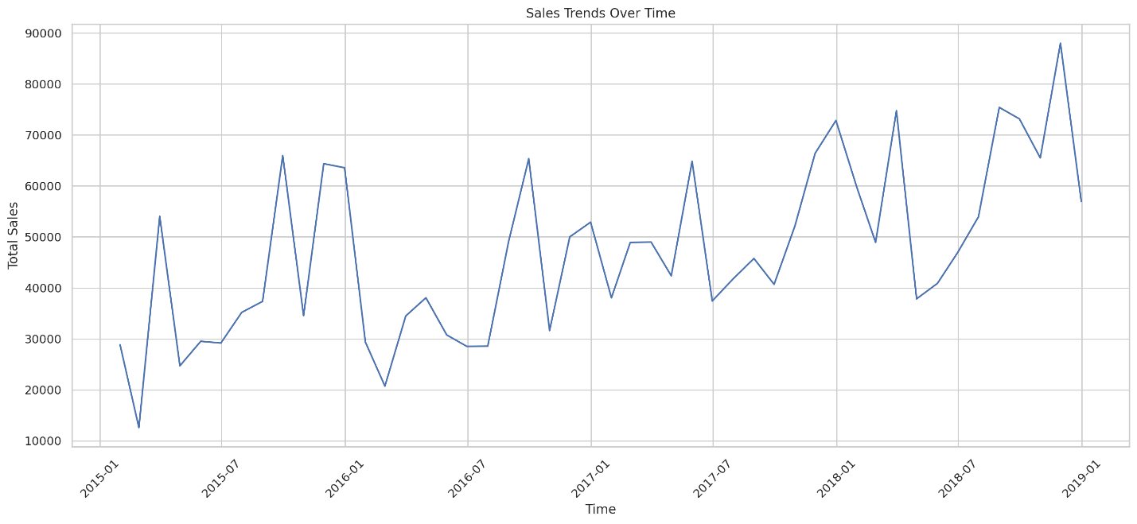

The relationship between shipping mode and total sales has been analyzed, with a visualization indicating the total sales for each shipping mode.

Total Sales by Shipping Mode:

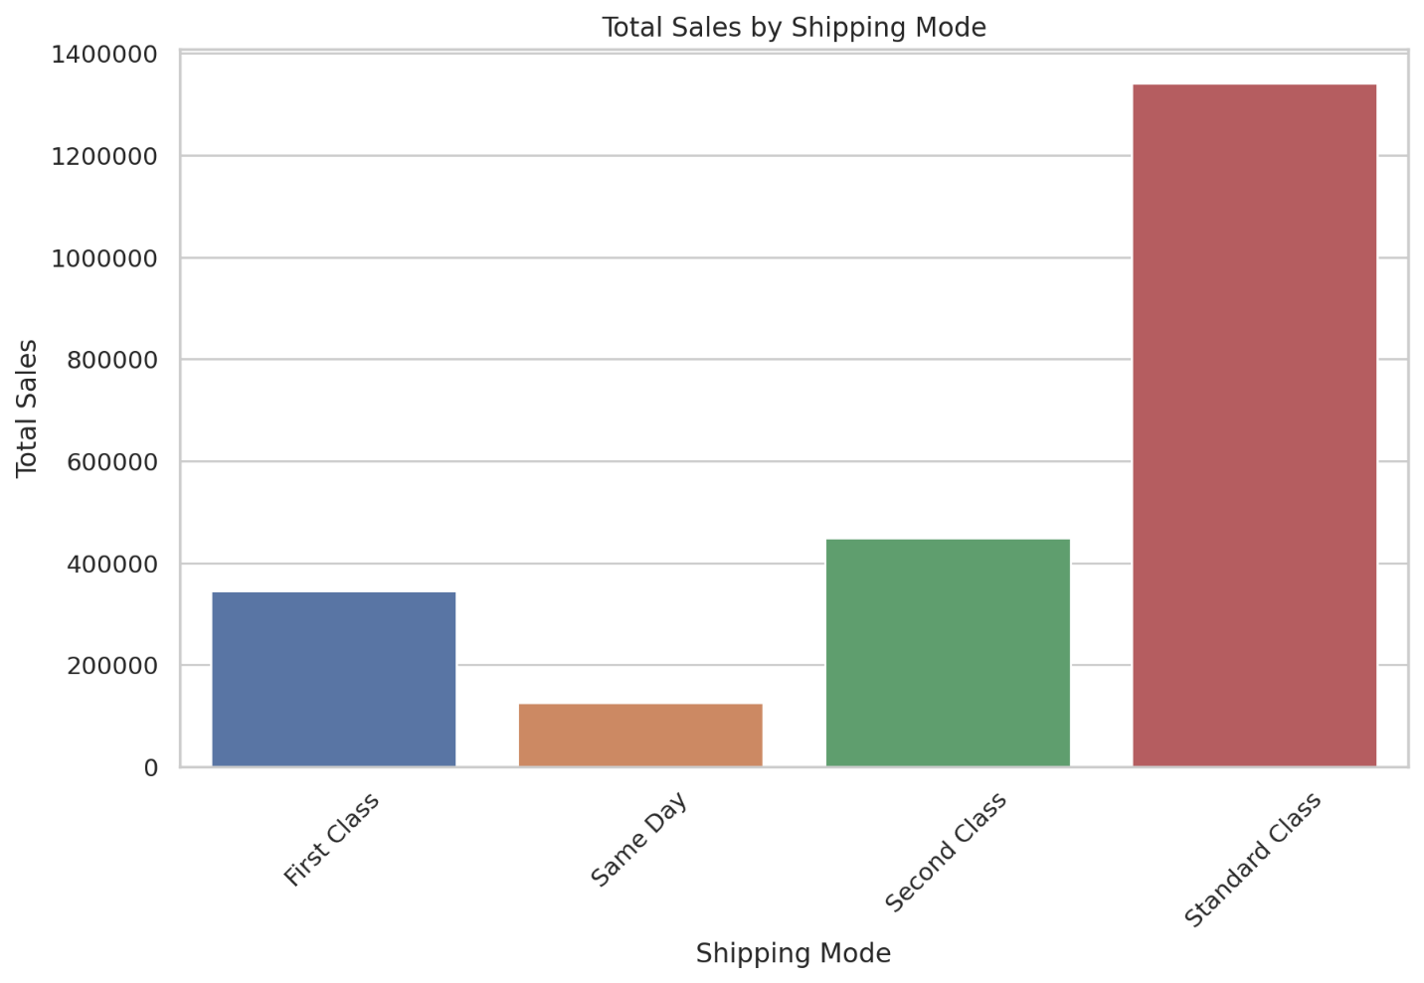

The total sales by customer segment have been segmented and visualized, showing the sales distribution across different customer segments.

Total Sales by Customer Segment:

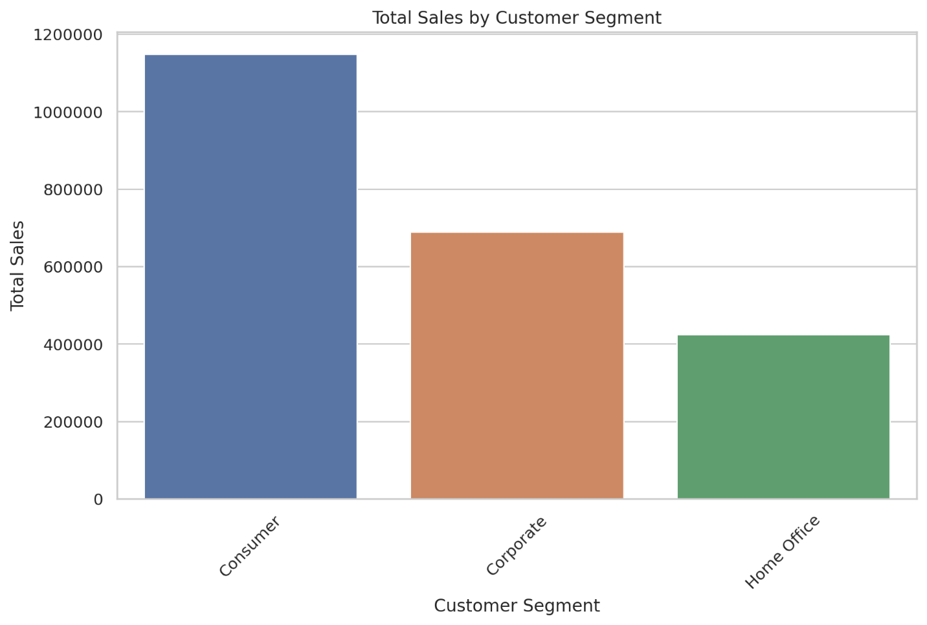

The sales performance by region has been explored, and a bar chart has been created to show the total sales in each region.

Total Sales by Region:

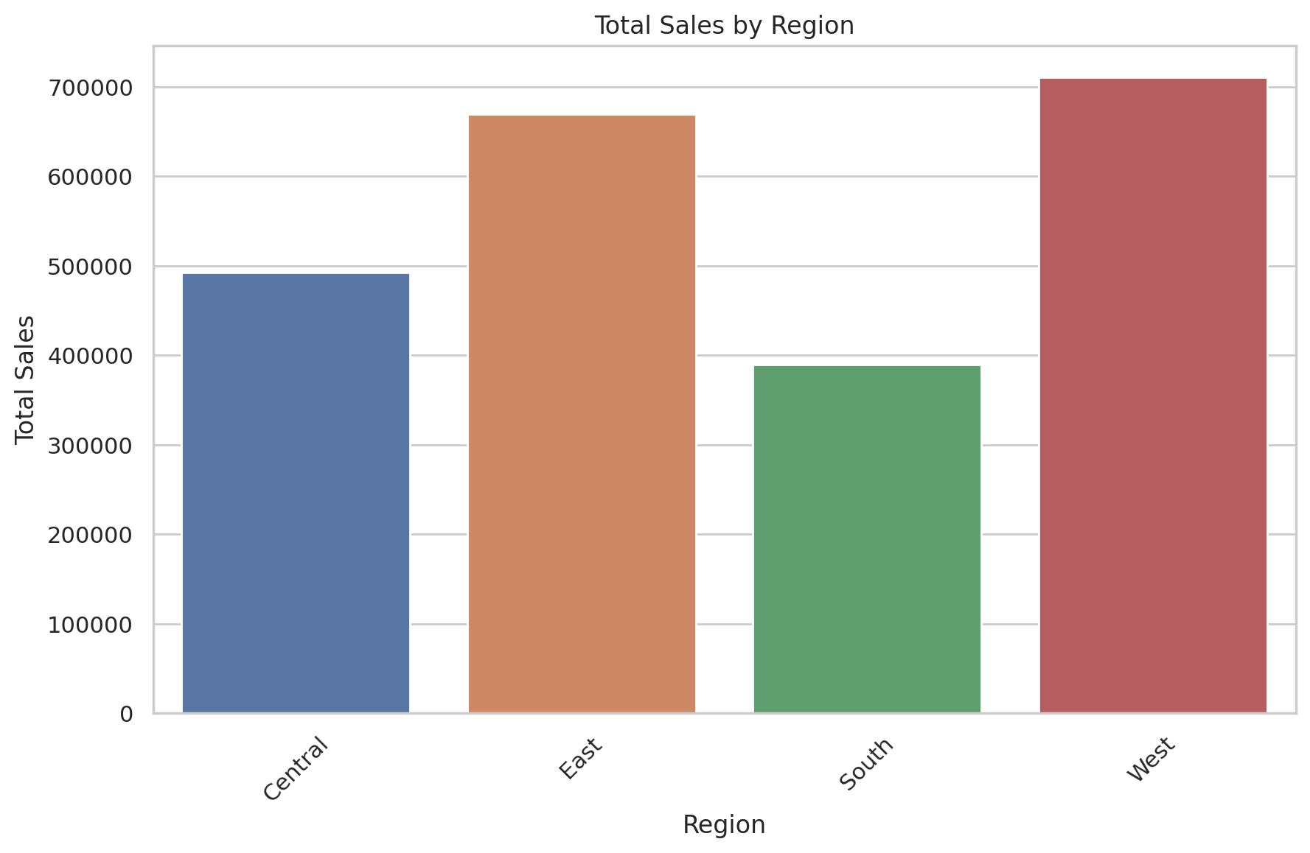

The top 5 cities with the highest sales are listed above.

Average sales per order:

230.76905945917886

The average sales per order is approximately $230.77.

| **Sales** |
| --- |
| **Product Name** |  |
| **Canon imageCLASS 2200 Advanced Copier** | 61599.824 |
| **Fellowes PB500 Electric Punch Plastic Comb Binding Machine with Manual Bind** | 27453.384000000002 |
| **Cisco TelePresence System EX90 Videoconferencing Unit** | 22638.48 |
| **HON 5400 Series Task Chairs for Big and Tall** | 21870.576 |
| **GBC DocuBind TL300 Electric Binding System** | 19823.479 |

The top 5 best-selling products have been identified based on total sales.

|  | **Sales** |
| --- | --- |
| **City** |  |
| **New York City** | 252462.547 |
| **Los Angeles** | 173420.181 |
| **Seattle** | 116106.322 |
| **San Francisco** | 109041.12 |
| **Philadelphia** | 108841.749 |

Here are the visualizations for the total sales per category and the top 5 cities with the highest sales:

Total Sales per Category:

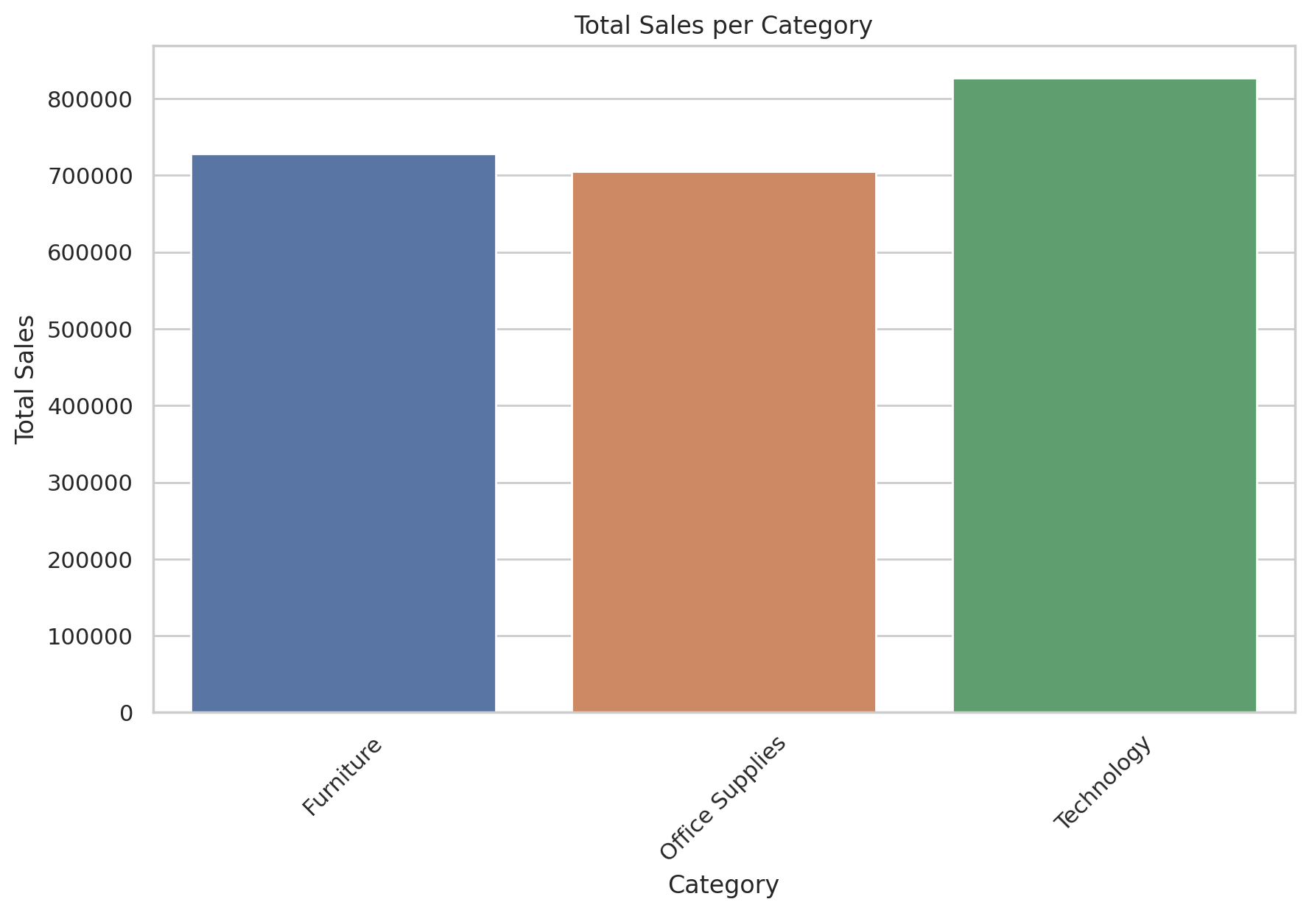

Top 5 Cities with the Highest Sales:

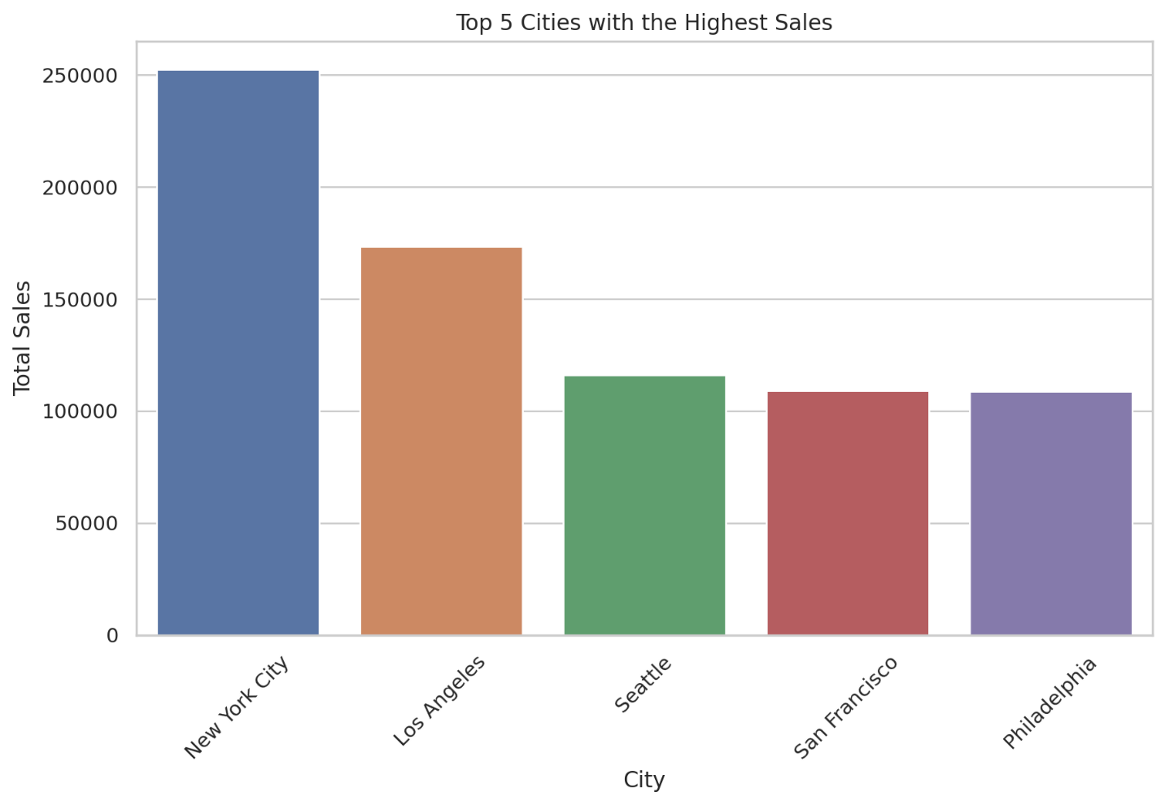

Distribution of Sales per Order with the average indicated by a red dashed line:

